Marshallese agroforestry calendar – El Nino

- This calendar shows how wind, waves and rain change during the onset and peak of an El Nino year, and the aftereffects of drought and reduced harvests the following year.
- The total El Nino phase takes about two years. When it ends, it does not cycle back on itself – it usually goes back to neutral or La Nina conditions, so go to the “normal” calendar.
- The Marshallese year is divided into two major seasons, Añōn Rak and Añōneañ. The El Nino year makes Rak early and wet, and the following year makes Anonean very long.
- The calendar focuses on harvest times of traditional crops, because they are perennial (not planted every year). Harvests are reduced by the El Nino drought.
- This calendar is very general for the Marshalls. Each atoll could have its own different calendar, especially since the northern atolls are drier and more affected by the El Nino drought.
(Graphic here)
Transition from normal calendar
Return to normal calendar
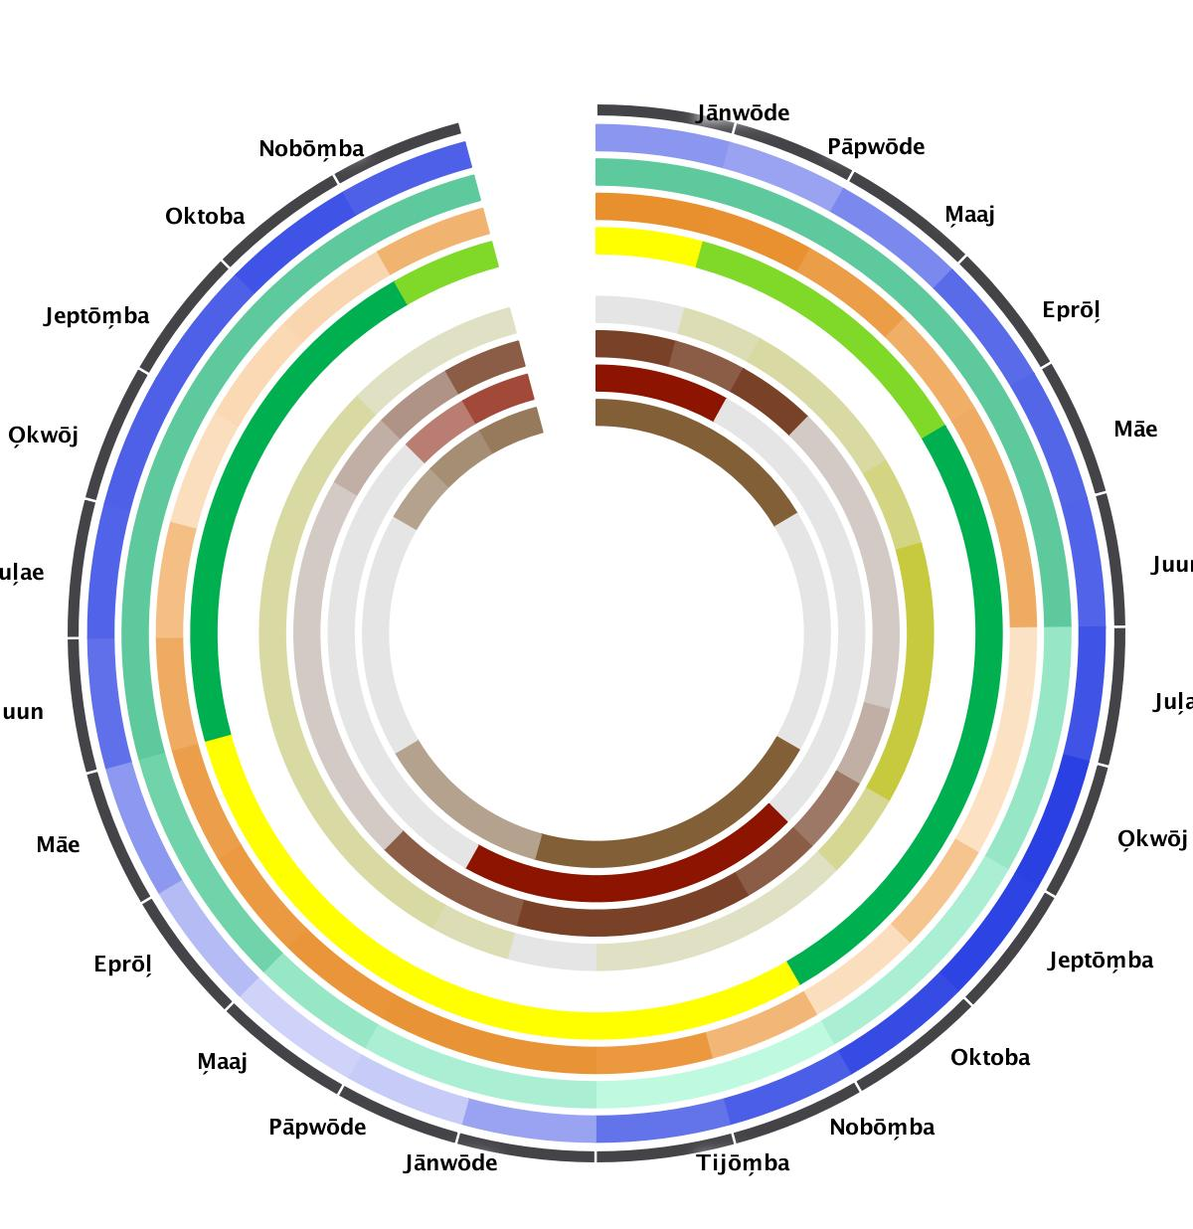

 |  | Jan | Feb | March | April | May | June | July | Aug | Sept | Oct | Nov | Dec
Average of Kwajelein & Majuro Rainfall  (mm/3 months centered on each month) | Year 0 | 472 | 421  dry | 518 | 626 | 645 | 661  wet | 715 | 789  Very wet | 782 | 754 | 678  wet | 602
 | Year 1 | 417  dry | 268  Very dry | 244  Very dry | 332 | 457 | 614 | 661 | 670 | 669 | 715 | 666 | 523
Strong El Nino sea levels relative to mean: (inches) | Year 0 | 0  average | 0 | 0 | 0 | 0 | 0 | -3 | -3 | -4 | -4 | -5  5 inches low | -5
Strong El Nino sea levels relative to mean: (inches) | Year 1 | -4 | -4 | -3 | -1 | -1 | 0 | 0 | 0 | 0 | 0 | 0 | 0
Average wind direction and speed (knots) – strong El Nino | Year 0 (March-Dec 2015) | 15.7  windy | 15.3 | 13.8 | 11.5 | 11.9 | 12.0 | 5.0  calm | 5.2 | 8.8 | 5.5 | 10.5 | 14.3
Average wind direction and speed (knots) – strong El Nino | Year 1  (Jan-Feb 2016) | 15.0 | 15.0 | 14.8 | 14.2 | 13.7 | 12.1 | 9.5 | 5.6 | 6.3 | 6.5 | 10.9 | 13.2
El Nino - Tropical storm probability. | Year 0 | Almost no risk | Almost no risk | Risk | Risk | Risk | Risk | Risk | Risk | Risk | Risk | Higher Risk | Higher Risk
El Nino - Tropical storm probability. | Year 1 | Higher Risk | Little risk | Almost no risk | Almost no risk | Almost no risk | Almost no risk | Almost no risk | Almost no risk | Almost no risk | Almost no risk | Almost no risk | Almost no risk
Wave train probability (Years 0 & 1) |  | Possible | Possible | Possible | Possible | Possible | more likely | more likely | more likely | Possible | Possible | Possible | Possible

Crop names |  | Jan | Feb | Mar | Apr | May | Jun | Jul | Aug | Sep | Oct | Nov | Dec
Named seasons
Named seasons | Year 0 | Anonean (Winter, Dry) | Early rains  (transition between yellow and green) |  |  | Rak (Summer, Wet) |  |  |  |  |  | Anonean (Winter, Dry)
Named seasons | Year 1 | Anonean (Winter, Dry) |  |  |  |  | Rak (Summer, Wet) |  |  |  |  | Anonean (Winter, Dry)
Breadfruit (Artocarpus spp.)
Breadfruit (Artocarpus spp.) | Year 0 | 0 | 3 | 4 | 4 | 6 | 9 | 9  More harvest | 8 | 5 | 2 | 2 | 2
Breadfruit (Artocarpus spp.) | Year 1 | 0  No harvest | 3 | 4 | 4 | 4 | 4  some harvest | 4 | 4 | 4 | 2 | 2  Less harvest | 2
Taro (Colocasia esculenta) | Year 0 |  |  | 1 | 1 | 2 | 2  more harvest | 2 | 2 | 1
Taro (Colocasia esculenta) | Year 1 |  |  |  |  | 1 | 1  Less harvest | 1 | 1 | 1
Giant land taro (Alocasia maccrorhiza | Year 0 | 2 | 2 | 2 | 2 |  | (see note below) |  |  | 2 |   mroe harvest | 2 | 2
Giant land taro (Alocasia maccrorhiza | Year 1 | 2 | 1 | 1  less harvest | 1 |  |  |  |  | 1 | 1.3 | 1.6 | 2
Pandanus tectorius
Pandanus tectorius | Year 0 | 8 | 7 | 6 | 2 | 2 | 2 | 2 | 4 | 6 | 7 | 8  more harvest | 8
Pandanus tectorius | Year 1 | 8 | 7 | 4 | 1 | 1 | 1  Less harvest | 1 | 2 | 3 | 4 | 6 | 8
PERENNIALS  (Coconut, banana…) | Year 0 | 2 | 2 | 2 | 2 | 2 | 2  harvest | 2 | 2 | 2 | 2 | 2 | 2
PERENNIALS  (Coconut, banana…) | Year 1 | 2 | 2 | 1 | 1 | 1 | 1  Less harvest | 1 | 1 | 1 | 1.3 | 1.6 | 2
Arrowroot (Tacca leontopetaloides)
Arrowroot (Tacca leontopetaloides) | Year 0 | 2 | 2 | 1 |  |  |  |  |  |  | 1 | 2 | 2  more harvest
Arrowroot (Tacca leontopetaloides) | Year 1 | 2 | 2 | 1 |  |  |  |  |  |  | .5 | 1.5 | 2

Note: Giant land taro (wōt) and some other crops could be harvested year round; this calendar shows them with harvest seasons during Añōneañ because people prefer to harvest other crops at other times.

